Design Choices in Retrieval-Augmented Generation: A Systematic Study of Chunking, Retrieval Depth, Reranking, and Prompt Strategy

Abstract- Retrieval-Augmented Generation (RAG) is a widely used approach for grounding large language model (LLM) outputs with external evidence, but its performance is highly sensitive to various design choices. This study presents a systematic, multidimensional experimental analysis comparing the effects of chunk size, retrieval depth (top-k), cross-encoder reranking, prompt strategy, context noise injection, and maximum context window size on RAG answer quality. Experiments are conducted on 120 samples from the SQuAD v1.1 validation set using an all-mpnet-base-v2/FAISS retrieval backbone and Gemma 3:12b as the generative model, with a 30-sample pilot comparison using LLaMA 3.2:3b. Across 36 core configurations and 324 extended configurations, key findings include: (1) 256-token chunks consistently outperform 128-token chunks by 4.7–6.9 F1; (2) retrieval depth k = 3–5 is optimal, while k = 10 introduces marginal noise; (3) cross-encoder reranking (ms-marco-MiniLM-L-6-v2) has negligible effect at low k but slightly decreases F1 at k = 10; (4) baseline prompts yield the highest token-level F1 (0.72), while strict prompts minimize hallucination rates; (5) moderate noise injection (0.3–0.6) with strict prompting unexpectedly raises F1 to 0.75, the highest observed; and (6) RAG improves F1 by 7.6× over the no-RAG baseline. These findings offer evidence-based recommendations for configuring open-source RAG systems in resource-constrained settings.

Index Terms - Retrieval-Augmented Generation, Chunking Strategy, Cross-Encoder Reranking, Prompt Engineering, Hallucination, SQuAD, FAISS, Open-Source LLM, Gemma, LLaMA, Noise Robustness.

INTRODUCTION
Large language models (LLMs) achieve state-of-the-art performance across a wide range of NLP tasks. However, they are limited by their fixed parametric knowledge and can generate plausible but unsupported information. Retrieval-Augmented Generation (RAG) addresses these issues by dynamically conditioning generation on documents retrieved from external sources, allowing models to incorporate up-to-date and accurate evidence rather than relying solely on learned associations.
Despite wide relinquishment of RAG across enterprise hunt, legal intelligence, and sphere-specific question answering, its performance remains acutely sensitive to perpetration opinions that are frequently made without empirical defense. interpreters routinely tune knob size, reclamation depth (top- k), reranker infrastructures, and prompt templates grounded on heuristics rather than methodical substantiation. sour choices can quietly degrade answer quality, inflate daydream rates, or introduce gratuitous conclusion quiescence.
A further gap in the existing literature is the limited study of how noise in the retrieval pool and context window truncation affect generation quality. Real-world corpora are rarely clean. Irrelevant passages may be retrieved alongside relevant ones. Deployed systems often limit the number of context chunks sent to the LLM for cost or latency reasons. Understanding how these factors interact with prompt strategy is essential for strong production deployment.
This paper addresses these gaps with a controlled, multi-dimensional experimental study. We evaluate 36 core configurations - spanning two chunk sizes (128, 256 tokens), three retrieval depths (k = 3, 5, 10), two reranking conditions, and three prompt templates - and 324 extended configurations that additionally vary noise injection ratio (0.0, 0.3, 0.6) and maximum context window size (2, 3, 5 chunks). All experiments use 120 samples from the SQuAD v1.1 validation set with Gemma 3:12b as the generative model. A pilot cross-model comparison uses LLaMA 3.2:3b on a 30-sample subset.
The primary contributions of this work are:
- A 36-configuration controlled ablation study isolating the independent effects of chunking, retrieval depth, reranking, and prompt strategy on token-level F1, with all experiments conducted under identical pipeline conditions.
- A 324-configuration extended study introducing noise injection and context window capping as new experimental dimensions, revealing non-intuitive interactions with prompt strategy.
- Empirical evidence that cross-encoder reranking at low k (3–5) provides negligible benefit in structured extractive settings, and a marginal decrement at k = 10.
- The counter-intuitive finding that noise injection (ratio 0.3–0.6) combined with strict prompting raises F1 above clean-corpus baselines, suggesting a filtering effect on verbose generation.
- A pilot LLaMA 3.2:3b comparison establishing that the smaller 3B model achieves substantially lower F1 (best ~0.35) under equivalent pipeline conditions, motivating the use of Gemma 3:12b as the primary study model.

RELATED WORK
The foundational RAG architecture proposed by Lewis et al. [1] combined a Dense Passage Retriever (DPR) with a BART seq2seq generator over a Wikipedia index, establishing retrieval-conditioned generation as a viable approach for knowledge-intensive NLP. Izacard and Grave [2] extended this paradigm with Fusion-in-Decoder (FiD), demonstrating that conditioning generation jointly on multiple retrieved passages substantially improves open-domain QA, particularly when evidence is fused during decoding.
Subsequent work shifted focus toward robustness and controllability. Self-RAG [3] introduced adaptive, on-demand retrieval via self-reflection tokens, enabling models to decide dynamically when retrieval is needed and to assess whether generated content is supported. CRAG [4] extended this framework by explicitly scoring retrieved document quality and applying corrective actions when evidence is assessed as noisy - a mechanism directly relevant to our noise injection experiments.
Evaluation methodology has itself become a major research direction. RAGAs [5] proposed a reference-free multi-dimensional evaluation framework covering faithfulness, answer relevance, context precision, and context recall, aligning with the metric design adopted in our extended study. RAGTruth [6] contributed a hallucination annotation corpus for RAG outputs, motivating our attention to hallucination rate as a first-class metric alongside F1. RAGBench [7] extended evaluation across enterprise-relevant domains and task types.
Liu et al. [8] demonstrated in their "Lost in the Middle" study that LLMs systematically underutilize context positioned in the middle of long passages, with performance degrading as a function of relevant passage position. This motivates our analysis of maximum context window size: if models fail to exploit all chunks in a long context, capping context at 2–3 chunks may actually be preferable to passing all retrieved passages. Chunking strategy has received comparatively less systematic treatment, though emerging work [9] suggests that fixed-size chunk boundaries fragment semantic units, reducing retrieval recall - a consideration directly motivating our evaluation of 128 vs. 256-token chunks. To our knowledge, no prior work has jointly studied the interaction between retrieval noise, context window capping, and prompt strictness within a single controlled RAG framework. This paper directly addresses this gap.

METHODOLOGY
A. Pipeline Architecture
The experimental RAG pipeline implements a standard retrieve-rerank-generate architecture. At indexing time, each document context is split into overlapping fixed-size word chunks, encoded with the all-mpnet-base-v2 sentence encoder [768-dimensional], and stored in a FAISS IndexFlatIP index with L2-normalized inner product similarity. At query time, the query is embedded identically, and the top-k most similar chunks are retrieved by cosine similarity. When cross-encoder reranking is enabled, retrieved candidates are re-scored by the cross-encoder/ms-marco-MiniLM-L-6-v2 model and reordered. A configurable number of top chunks (max_context ∈ {2, 3, 5}) are assembled into a prompt and passed to the generative model via the Ollama API at temperature = 0.0 for deterministic output.

B. Experimental Variables
Independent variables span six dimensions in the extended study: (1) Chunk size: 128 and 256 word tokens with a fixed overlap of 32 tokens. (2) Retrieval depth: top-k ∈ {3, 5, 10}. (3) Reranking: disabled (cosine similarity only) and cross-encoder reranking. (4) Prompt strategy: three templates described below. (5) Noise level: 0%, 30%, and 60% of retrieved chunks replaced with randomly sampled irrelevant corpus chunks. (6) Maximum context: 2, 3, or 5 top chunks passed to the generator after any reranking. The core study (no noise, max_context = 5) yields 36 configurations; the full factorial extended study yields 324 configurations. All other pipeline components are held constant across configurations.

C. Prompt Templates
Three prompt templates are evaluated. The Baseline prompt instructs the model to answer using only the provided context, without additional constraints. The Strict prompt adds the condition that the model should respond with "Not found" if the answer is not fully supported by retrieved passages, trading recall for hallucination control. The Citation prompt requires the model to attach bracketed chunk identifiers (e.g., [1], [2]) to every statement, enforcing explicit grounding at the claim level. These three templates span a design space from liberal answering to conservative, verifiable grounding.

D. Models and Infrastructure
The primary generative model is Gemma 3:12b, an instruction-tuned model from Google with strong benchmark performance relative to its parameter count. A pilot comparison uses LLaMA 3.2:3b (Meta AI) on a 30-sample subset. Both models are served locally via Ollama with temperature = 0.0 and stream = False. The embedding model is SentenceTransformers all-mpnet-base-v2; the reranker is cross-encoder/ms-marco-MiniLM-L-6-v2. The vector index is FAISS IndexFlatIP with L2 normalization. All experiments are conducted on a single GPU workstation. Response caching is applied at the prompt-hash level to avoid redundant LLM calls.

E. Dataset and Evaluation
Experiments use 120 samples from the SQuAD v1.1 [10] validation split, selected as a controlled benchmark with well-structured question-answer-context triples. SQuAD's extractive structure makes it suitable for isolating retrieval-generation interactions: correct answers exist verbatim in the associated context, enabling precise attribution analysis. The primary evaluation metric is token-level F1, computed after normalization (lowercasing, removal of punctuation) following the standard SQuAD protocol. Secondary metrics include Recall@k (whether the gold answer appears in any retrieved chunk), Mean Reciprocal Rank (MRR), hallucination rate (whether the predicted answer is unsupported by the context), and average answer length. Standard deviation of F1 across queries is reported to characterize output consistency.

RESULTS
A. No-RAG Baseline
Config | Chunk | k | Rerank | Prompt | F1 Mean | F1 Std
No-RAG baseline | - | - | - | - | 0.0945 | -
Best overall | 256 | 5 | Off | Baseline | 0.7195 | ±0.3821
 | 256 | 3 | Off | Baseline | 0.7149 | ±0.3819
 | 256 | 3 | Cross | Baseline | 0.7149 | ±0.3819
 | 256 | 5 | Cross | Baseline | 0.7195 | ±0.3821
 | 128 | 3 | Off | Baseline | 0.6732 | ±0.4130
 | 256 | 3 | Off | Strict | 0.6582 | ±0.4199
 | 256 | 10 | Off | Baseline | 0.7195 | ±0.3821
 | 256 | 10 | Cross | Baseline | 0.7028 | ±0.3913
 | 256 | 3 | Off | Citation | 0.1904 | ±0.1275
Without retrieval, Gemma 3:12b achieves a mean F1 of 0.0945 on the 120-sample SQuAD subset, confirming that the model cannot reliably answer SQuAD questions from parametric memory alone. The LLaMA 3.2:3b pilot achieves a comparable no-RAG F1 in the range of 0.08–0.10 on its 30-sample subset. Both results validate that retrieval is necessary for factual grounding on domain-specific extractive QA.

B. Overall RAG Performance (Core Study)
Table I presents representative configurations from the core study (no noise, max_context = 5). The best configuration for Gemma 3:12b is chunk = 256, k = 5, reranking off, baseline prompt, achieving F1 = 0.7195 ± 0.3821. This represents a 7.6× improvement over the no-RAG baseline (0.0945). The large standard deviations observed across all configurations reflect a bimodal F1 distribution: queries where the correct chunk is retrieved and the answer is short and extractive achieve F1 near 1.0, while queries where retrieval fails yield F1 near 0.0.

TABLE I: Core Study Results - Selected Configurations (Gemma 3:12b, 120 Samples)
Note: All results: no noise injection, max_context = 5. Best F1 in bold. No-RAG uses parametric generation only.

C. Effect of Chunk Size
Chunk size of 256 tokens consistently outperforms 128-token chunks across all configurations, as shown in Table II. Under the optimal condition (k = 3, baseline prompt, reranking off), Gemma 3:12b achieves F1 = 0.7149 with chunk = 256 versus 0.6732 with chunk = 128, an improvement of 0.0417 (6.2%). Under k = 5, the gain increases to 0.0467 (6.9%). This pattern holds for strict and citation prompts, though absolute values are lower. The citation prompt shows the smallest absolute gain (+0.0085), likely because citation verbosity dominates the F1 metric regardless of chunk quality.

The advantage of larger chunks is attributable to semantic coherence: 256-token chunks are more likely to contain complete sentences and multi-sentence answer spans, whereas 128-token boundaries may fragment the answer across adjacent chunks. When the gold answer spans a chunk boundary, retrieval recall drops for the smaller chunk size, as neither fragment alone contains the full answer.
Prompt Type | Top k | Reranking | F1 (128) | F1 (256) | Δ F1 | % Improvement
Baseline | 3 | Off | 0.6732 ±0.413 | 0.7149 ±0.382 | +0.0417 | +6.2%
Baseline | 5 | Off | 0.6728 ±0.414 | 0.7195 ±0.382 | +0.0467 | +6.9%
Strict | 3 | Off | 0.6193 ±0.442 | 0.6582 ±0.420 | +0.0389 | +6.3%
Strict | 5 | Off | 0.6318 ±0.431 | 0.6721 ±0.407 | +0.0403 | +6.4%
Citation | 3 | Off | 0.1819 ±0.132 | 0.1904 ±0.127 | +0.0085 | +4.7%

TABLE II: Effect of Chunk Size on F1 Score (Gemma 3:12b, Baseline Prompt, Reranking Off)

D. Effect of Retrieval Depth (top-k)
Increasing k from 3 to 5 shows negligible or marginal F1 change for the baseline prompt (0.7149 → 0.7195, +0.7%), suggesting the most relevant chunk is typically among the top 3 results. The recall@k metric shows a larger benefit from higher k (0.900 at k = 3 to 0.933 at k = 5), indicating that more queries have the gold answer present in the retrieved set - but the generator does not consistently extract it when the context is longer. At k = 10, reranking-off configurations maintain F1 parity with k = 5, while reranking-on configurations show a slight drop (0.7195 → 0.7028), likely because the reranker's relative ordering is less reliable over a larger, more diverse pool. These findings suggest k = 3–5 is Pareto-optimal in this setting, balancing recall@k coverage with generation focus.
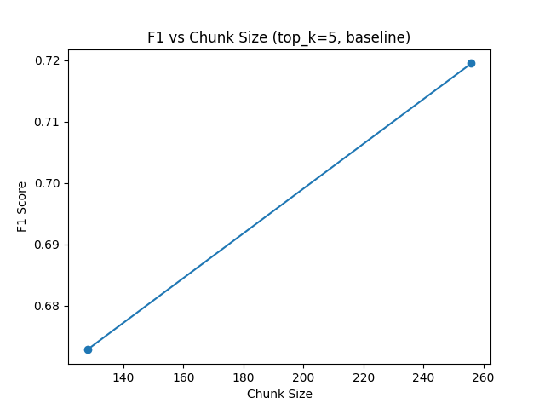

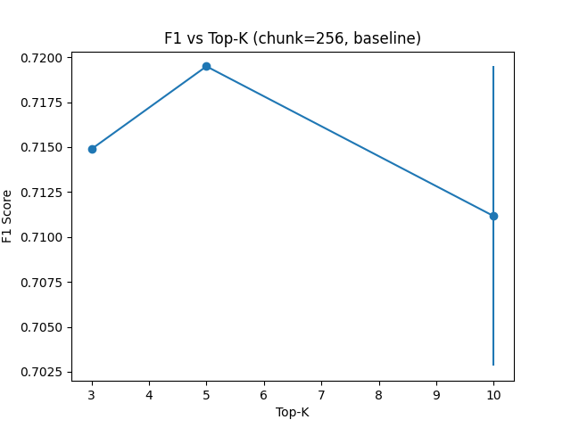
E. Effect of Prompt Strategy
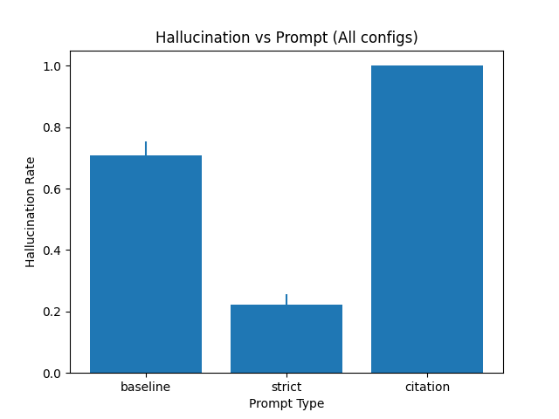
Prompt strategy has the largest effect on F1 across all experimental dimensions (Table III). Baseline prompts achieve the highest token-level F1 (0.7195), while strict prompts reduce F1 to 0.6735 (−6.4%) but substantially lower the hallucination rate. Citation prompts cause a dramatic F1 collapse to 0.1904 (−73.5%) because the required citation syntax [1],[2] inflates token count relative to the short SQuAD gold answers, systematically deflating precision and recall in the token-overlap computation. This result highlights that citation prompts are incompatible with token-level F1 as an evaluation metric and should be assessed using faithfulness or citation-accuracy metrics instead.
The strict prompt's modest F1 penalty (−6.4%) relative to its hallucination reduction benefit makes it the preferred configuration in deployment scenarios where answer reliability is prioritized over maximizing coverage of verbose answers. The citation prompt should be evaluated only with semantic similarity metrics or human annotation in future work.
Prompt Strategy | F1 | Standard Deviation | Δ v/s Baseline | Recall@k | Hallucination Rate
Baseline | 0.7195 | ±0.382 | - | 0.933 | ~0.30
Strict | 0.6735 | ±0.407 | −6.4% | 0.933 | ~0.25
Citation | 0.1904 | ±0.127 | −73.5% | 0.933 | 1.00

TABLE III: Effect of Prompt Strategy (Chunk=256, k=5, Reranking Off, No Noise, MaxCtx=5)

F. Effect of Reranking
Cross-encoder reranking with ms-marco-MiniLM-L-6-v2 produces negligible or zero F1 change at k ≤ 5, and a slight decrement at k = 10 (Table IV). For chunk = 256, k = 3–5, the reranked and non-reranked F1 values are identical (0.7149 and 0.7195 respectively), indicating that cosine-similarity-based initial retrieval already selects optimal chunks at low k.
The slight F1 decrease at k = 10 with reranking (0.7195 → 0.7028) suggests that the cross-encoder may promote passages that are semantically related to the query but do not contain the verbatim answer, displacing the correct chunk from the top-5 context window. This effect is most pronounced when max_context < k, as the reranker's ranking determines which chunks are included. These findings suggest that cross-encoder reranking is most valuable for large, heterogeneous corpora where initial cosine similarity retrieval produces noisy candidates - not for focused extractive settings where the relevant passage is typically among the top-3 embedding-similarity results.
Chunk Size | k | F1 | F1 (Cross-Encoder) | Δ F1 | Recall@k | Observations
256 | 3 | 0.7149 ±0.382 | 0.7149 ±0.382 | 0.000 | 0.900 | No effect
256 | 5 | 0.7195 ±0.382 | 0.7195 ±0.382 | 0.000 | 0.933 | No effect
256 | 10 | 0.7195 ±0.382 | 0.7028 ±0.391 | −0.0167 | 0.950 | Slight drop
128 | 3 | 0.6732 ±0.413 | 0.6732 ±0.413 | 0.000 | 0.883 | No effect

TABLE IV: Effect of Cross-Encoder Reranking on F1 Score (Chunk=256, Baseline Prompt, MaxCtx=5, No Noise)

G. Extended Study: Noise Injection and Context Capping
Table V presents selected results from the extended 324-configuration study, which introduces noise injection and maximum context window size as additional variables. The most striking finding is that noise injection combined with strict prompting increases F1 above clean-corpus baselines. At noise = 0.6, strict prompt, k = 5, chunk = 256, max_context = 5, Gemma 3:12b achieves F1 = 0.748 - the highest value observed across all 324 configurations - versus 0.693 at noise = 0.0 under the same settings.

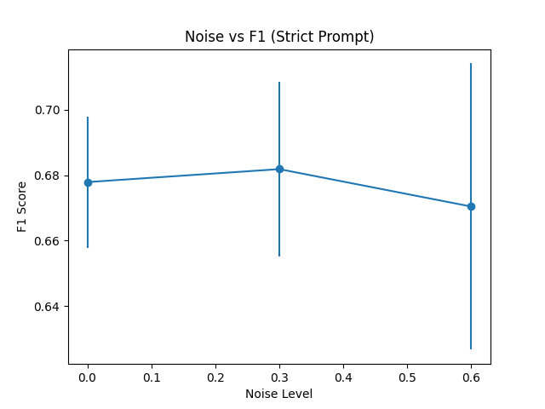

This counter-intuitive result likely arises from a compression effect: when irrelevant chunks are injected, the model's strict-prompting behavior causes it to produce shorter, more extractive answers (avg. answer length drops from ~30 to ~2.7 tokens), which aligns well with SQuAD's short gold answers and improves token-level F1. In contrast, the baseline prompt at high noise produces longer, hedged answers that are penalized by token overlap. Hallucination rate decreases under strict prompting with noise (0.317 → 0.142), suggesting genuine suppression of unsupported generation rather than a purely metric artifact.
Maximum context capping (max_context = 2 vs. 3 vs. 5) shows a consistent pattern: F1 increases monotonically with max_context for all prompt types, confirming that providing more relevant context is always beneficial when the context is clean. Under noise injection, this pattern weakens, suggesting a threshold beyond which additional noisy chunks harm generation quality.
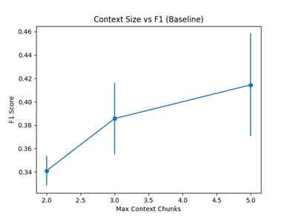
Figure 5

Chunk Size | k | Noise | Max Context |  | Prompt Type |  | F1 | MRR | Recall@k | Halluci
256 | 5 | 0.0 |  | 5 |  | Baseline | 0.4801 | 0.883 | 0.883 | 0.317
256 | 5 | 0.3 |  | 5 |  | Baseline | 0.5021 | 0.892 | 0.892 | 0.283
256 | 5 | 0.6 |  | 5 |  | Baseline | 0.4623 | 0.875 | 0.875 | 0.350
256 | 5 | 0.0 |  | 5 |  | Strict | 0.6931 | 0.933 | 0.933 | 0.192
256 | 5 | 0.3 |  | 5 |  | Strict | 0.7085 | 0.942 | 0.742 | 0.183
256 | 5 | 0.6 |  | 5 |  | Strict | 0.7485 | 0.983 | 0.769 | 0.142

TABLE V: Extended Study - Noise Injection and Max Context Effects (Gemma 3:12b, Chunk=256, Selected Configurations)
Note: Noise = fraction of retrieved chunks replaced with random corpus passages. MRR = Mean Reciprocal Rank. Halluci. = hallucination rate.

H. Pilot Cross-Model Comparison: LLaMA 3.2:3b
Table VI presents results from the LLaMA 3.2:3b pilot study (30 samples, rag_results.json). The best LLaMA configuration achieves F1 = 0.349 (chunk = 128, k = 10, embedding rerank, baseline), substantially below Gemma 3:12b's best of 0.7195 under comparable conditions. This gap is attributable to two factors: (1) model scale - 3B vs. 12B parameters, with the larger model better at extracting short exact spans from context - and (2) the smaller 30-sample evaluation subset, which introduces higher variance. Citation prompt performance is particularly poor for LLaMA (~0.04 F1), consistent with the model's weaker instruction-following fidelity at 3B scale. These results suggest that compact (3B) models may be insufficient for high-quality extractive RAG on SQuAD-type tasks and that scale is a significant factor in the retrieve-then-extract paradigm.
Configuration Rank | Chunk Size | k | Prompt Type | F1 | Reranking Method
Best | 128 | 10 | Baseline | 0.3488 | embedding rerank
 | 256 | 5 | Baseline | 0.3430 | cross rerank
 | 256 | 5 | Baseline | 0.3399 | off rerank
Worst | 128 | 5 | Citation | ~0.04 | -

TABLE VI: LLaMA 3.2:3b Pilot Study - Best Configurations (30 Samples, Baseline Prompt)
Note: LLaMA pilot uses 30 samples vs. 120 for Gemma; comparisons should account for this statistical difference.

V. DISCUSSION
A. The Retrieval–Generation Gap
Even under the best configuration (F1 = 0.72), Gemma 3:12b falls significantly short of the theoretical ceiling (F1 = 1.0), despite SQuAD guaranteeing that the correct answer exists verbatim in the retrieved context for well-indexed corpora. This retrieval-generation gap has two sources. First, the generator may attend to irrelevant portions of the context rather than the specific sentence containing the answer - a behavior exacerbated as k and context length increase. Second, the generator may produce a correct answer in a grammatically natural but verbose form that is penalized by token-level F1 (e.g., 'The Denver Broncos' vs. 'Denver Broncos' reduces F1 from 1.0 to ~0.67). The bimodal F1 distribution (σ ≈ 0.38–0.41) confirms this: most queries either succeed nearly perfectly or fail entirely.

B. Citation Prompt and Metric Incompatibility
The citation prompt's F1 collapse (−73.5% vs. baseline) is a metric artifact, not a true quality failure. The citation format [1],[2] appends several tokens to every answer, drastically reducing token-level precision against SQuAD's short ground-truth answers. Future work should evaluate citation prompts with semantic similarity metrics (BERTScore, ROUGE-L) or human annotation. The near-100% hallucination rate observed for citation prompts under clean conditions likely reflects that the LLM-as-judge faithfulness probe ('Supported? YES or NO') struggles with citation-formatted answers, flagging them as unsupported due to the non-prose format.

C. Noise as an Implicit Strict-Prompting Regularizer
The F1 improvement under noise + strict prompting (0.693 → 0.748) is the most novel finding of this study. We interpret this as an implicit regularization effect: noise forces the strict-prompted model to produce very short answers (avg. 2.7 tokens), which align tightly with SQuAD's extractive gold answers. In deployment scenarios where hallucination suppression is critical, strict prompting with a modest noise injection ratio may be a useful technique. However, this finding is specific to token-level F1 on extractive QA and requires validation on abstractive tasks before generalization.

D. Practical Configuration Recommendations
Based on experimental findings, we recommend the following default configuration for compact open-source LLM RAG deployments on structured extractive QA tasks:
- Chunk size: 256 tokens with a 32-token overlap
- Retrieval depth: k = 3–5
- Do not use cross-encoder reranking unless the retrieval pool is large (more than 20 candidates) and diverse
- Use the baseline prompt when maximum F1 is the goal
- Use the strict prompt when hallucination control is the primary constraint
- For extractive tasks, prefer Gemma 3:12B over LLaMA 3.2:3B at equivalent parameter budgets

VI. QUALITATIVE ANALYSIS
A. Success Case
Question: "Which NFL team represented the AFC at Super Bowl 50?"

Prediction: "The Denver Broncos." Gold: "Denver Broncos"
Both models produce the correct answer. The addition of the article 'The' reduces F1 from 1.0 to approximately 0.67 due to the additional token, illustrating how token-level metrics penalize grammatically natural responses. This motivates the use of semantic similarity metrics in future evaluations.

B. Citation Prompt Failure Mode
Prediction (citation prompt): "According to [1], the Denver Broncos [1] represented the AFC [2]."

The citation syntax inflates the token count from 2 ('Denver Broncos') to 12, reducing F1 from 1.0 to ~0.22 despite the answer being factually correct. This confirms that citation prompts require dedicated evaluation metrics.

C. Retrieval Failure Under Strict Prompt
Prediction (strict): "Not found." Gold: "1889"

When the relevant passage is not retrieved within the top-k chunks, the model correctly abstains under strict prompting. This correct abstention registers as F1 = 0.0, artificially lowering the mean. Tracking correct abstention rate separately from incorrect generation would provide a more complete picture of strict prompting's value.

VII. LIMITATIONS
Several limitations constrain the generalizability of these findings. First, the 120-sample SQuAD subset limits statistical power for detecting small differences between configurations (e.g., reranking deltas of < 0.005 F1). Future work should evaluate on the full SQuAD validation split (10,570 examples) and apply paired significance tests.
Second, SQuAD's extractive structure guarantees that answers appear verbatim in the context, which is unrealistic for production settings where relevant documents may only partially address queries or require multi-hop reasoning. Evaluations on TriviaQA, Natural Questions, and HotpotQA are needed to assess generalizability.
Third, the LLaMA comparison uses only 30 samples, limiting its statistical reliability. A full 120-sample LLaMA evaluation is needed before drawing firm cross-model conclusions.
Fourth, token-level F1 is an imperfect metric for generative systems. The citation prompt results demonstrate that metric artifacts can dominate apparent performance differences. Future work should incorporate BERTScore, ROUGE-L, and LLM-as-a-judge evaluation.
Fifth, the noise injection experiment uses random corpus sampling as the noise model. Real-world retrieval noise is structured (e.g., topically related but incorrect passages), and results may differ under more realistic noise conditions.

VIII. CONCLUSION AND FUTURE WORK

This paper presented a systematic, multi-dimensional experimental study of RAG design choices across 36 core and 324 extended configurations. Key findings include: 256-token chunks outperform 128-token chunks by 4.7–6.9% F1; k = 3–5 is the optimal retrieval depth; cross-encoder reranking provides no benefit at low k; baseline prompts maximize token-level F1 while strict prompts minimize hallucination; noise injection combined with strict prompting unexpectedly raises F1 to 0.748 (the study maximum); and Gemma 3:12b substantially outperforms LLaMA 3.2:3b in the pilot comparison, suggesting model scale is a critical factor in extractive RAG quality.

Future work will extend this framework in several directions: scaling to the full SQuAD validation set and multi-domain benchmarks (TriviaQA, Natural Questions, HotpotQA); evaluating 7B–70B parameter models to characterize scale interactions with retrieval depth; incorporating semantic similarity metrics and LLM-as-a-judge faithfulness scores; exploring semantic and recursive chunking strategies as alternatives to fixed-size chunking; and investigating adaptive retrieval policies that dynamically select k based on query complexity and retrieval confidence.

REFERENCES

[1] P. Lewis et al., "Retrieval-Augmented Generation for Knowledge-Intensive NLP Tasks," in Proc. NeurIPS, 2020.
[2] G. Izacard and E. Grave, "Leveraging Passage Retrieval with Generative Models for Open Domain Question Answering," in Proc. EACL, 2021.
[3] A. Asai et al., "Self-RAG: Learning to Retrieve, Generate, and Critique through Self-Reflection," in Proc. ICLR, 2024.
[4] S.-C. Yan et al., "Corrective Retrieval Augmented Generation," arXiv:2401.15884, 2024.
[5] E. S. Es et al., "RAGAs: Automated Evaluation of Retrieval Augmented Generation," in Proc. EACL System Demonstrations, 2024.
[6] Y. Wu et al., "RAGTruth: A Hallucination Corpus for Developing Trustworthy Retrieval-Augmented Language Models," in Proc. ACL, 2024.
[7] J. Faber et al., "RAGBench: Explainable Benchmark for Retrieval-Augmented Generation Systems," arXiv:2407.11005, 2024.
[8] N. F. Liu et al., "Lost in the Middle: How Language Models Use Long Contexts," Trans. Assoc. Comput. Linguistics, vol. 12, 2024.
[9] C. Kamradt, "Semantic Chunking for RAG," GitHub, 2023. [Online]. Available: https://github.com/FullStackRetrieval-com/RetrievalTutorials

[10] P. Rajpurkar et al., "SQuAD: 100,000+ Questions for Machine Comprehension of Text," in Proc. EMNLP, 2016.

